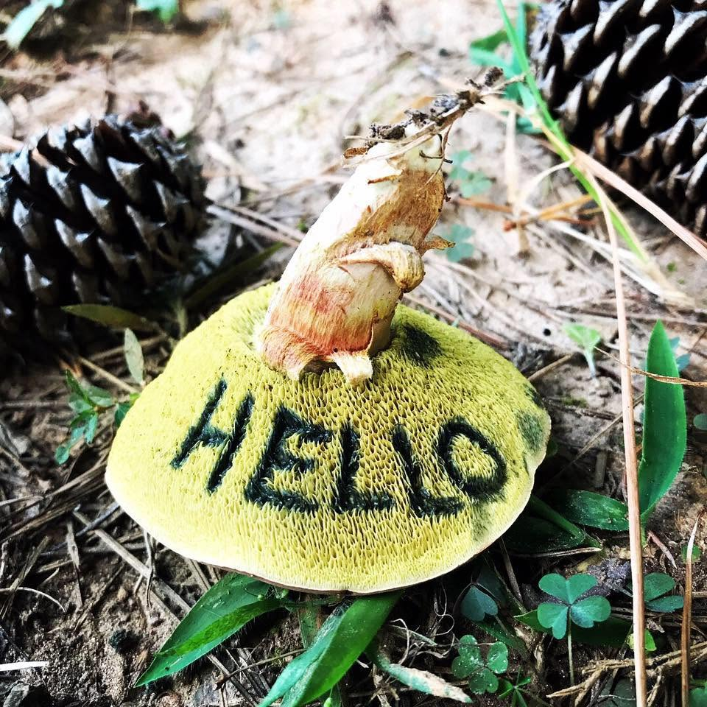 | OUTDOOR RE-EDUCATION  PARTICIPANT ACKNOWLEDGMENT, ASSUMPTION OF RISK, RELEASE & INDEMNITY AGREEMENT
PLEASE READ CAREFULLY. THIS AGREEMENT AFFECTS YOUR LEGAL RIGHTS AND INCLUDES A RELEASE OF CLAIMS ARISING FROM ORDINARY NEGLIGENCE.

1. Participant & activity information
Participant full legal name  ________________________________________ | Date of birth  ________________________________________
Activity / program  ________________________________________ | Activity date(s)  ________________________________________
Location  ________________________________________ | Mobile phone  ________________________________________
Emergency contact name  ________________________________________ | Emergency contact phone  ________________________________________
Program type (check all that apply):
☐ Foraging / plant walk | ☐ Foraging workshop | ☐ Bushcraft | ☐ Wilderness survival

2. Health, readiness & participant responsibilities
I certify that I am physically and mentally able to participate, or that I have disclosed any condition, limitation, allergy, medication, dietary restriction, or other concern that may affect safe participation. I will notify Outdoor Re-Education of any relevant change before the activity. I understand that Outdoor Re-Education does not provide medical advice and that I am responsible for deciding whether to seek clearance from a qualified medical professional.
I agree to follow instructor directions, use equipment only as directed, remain within designated areas, disclose when I do not understand an instruction, and stop participating when I believe I cannot continue safely. I accept responsibility for my clothing, personal equipment, hydration, medications, transportation, and medical expenses unless otherwise required by law.

3. Acknowledgment of inherent and other risks
Outdoor education takes place in changing natural environments. I understand that participation may involve known and unknown risks, including serious injury, illness, permanent disability, property loss, or death. Risks may include:
- uneven or steep terrain; falls; falling limbs; sharp plants; thorns; insects, ticks, snakes, wildlife, and animal-borne illness;
- heat, cold, rain, wind, lightning, darkness, dehydration, exposure, getting lost, delayed evacuation, and limited communications or medical access;
- cuts, burns, smoke exposure, splinters, strains, lifting, digging, chopping, sawing, knife or axe use, fire building, shelter construction, and camp cooking;
- allergic reactions, foodborne illness, poisonous or misidentified plants or fungi, contamination, and adverse reactions to harvested or prepared materials;
- acts or omissions of other participants, landowners, volunteers, contractors, or members of the public; and travel, site, equipment, or weather-related hazards.
I understand that this list is illustrative, not exhaustive. I voluntarily choose to participate and knowingly assume the inherent risks of the activity, including risks that cannot be eliminated without changing its essential nature.

4. Release of liability for ordinary negligence
In consideration for being permitted to participate, I release and discharge Outdoor Re-Education and its owner, instructors, employees, volunteers, agents, representatives, and activity hosts (collectively, the “Released Parties”) from claims for personal injury, death, or property damage arising from my participation to the extent caused by the ordinary negligence of a Released Party, including negligent instruction, supervision, equipment selection, site selection, or emergency response.
This release does not apply to gross negligence, recklessness, willful or intentional misconduct, or any liability that cannot lawfully be released.

5. Indemnity for participant conduct
To the extent permitted by law, I agree to indemnify and hold the Released Parties harmless from third-party claims, losses, or expenses arising from my negligent or intentional acts, my violation of instructions, my unauthorized use of equipment, or my material failure to disclose relevant health or safety information. This paragraph does not require me to indemnify a Released Party for that party’s own gross negligence, recklessness, or intentional misconduct.

6. Emergency care
If I am unable to consent during an emergency, I authorize Outdoor Re-Education personnel to contact emergency services and to provide reasonable first-aid assistance within their training while awaiting professional care. I understand that evacuation or treatment may be delayed by terrain, weather, distance, or communications limitations, and I accept responsibility for resulting medical and transportation costs unless otherwise required by law.

7. South Carolina law; severability
This Agreement is governed by South Carolina law. If a provision is found unenforceable, it will be modified only to the minimum extent necessary or severed, and the remaining provisions will continue in effect. This Agreement is the entire agreement concerning the subjects addressed here and may be changed only in a writing signed by the participant and Outdoor Re-Education.

8. Optional photo and media permission
☐ YES — I permit Outdoor Re-Education to use photographs or video of me for lawful educational, editorial, website, and promotional purposes without compensation.
☐ NO — I do not grant media permission. I understand reasonable efforts will be made to avoid identifiable use of my image.

9. Participant acknowledgment & signature
I have had the opportunity to ask questions. I have read and understand this Agreement, including the release of ordinary-negligence claims, and sign it voluntarily.
Participant signature  ________________________________________ | Date  ________________________________________
Printed name  ________________________________________ | Mobile phone  ________________________________________
Email  ________________________________________ | Activity date(s)  ________________________________________

10. Parent or legal guardian — participant under 18
I am the participant’s parent or legal guardian. I consent to the minor’s participation and acknowledge the activity risks described above. I sign this Agreement for myself and, only to the extent permitted by South Carolina law, on behalf of the minor.
Parent / guardian signature  ________________________________________ | Date  ________________________________________
Printed name  ________________________________________ | Relationship to minor  ________________________________________
Email  ________________________________________ | Mobile phone  ________________________________________
Bring the completed agreement to your activity unless Outdoor Re-Education provides another submission method. Participation may be declined if required information or signatures are incomplete.

